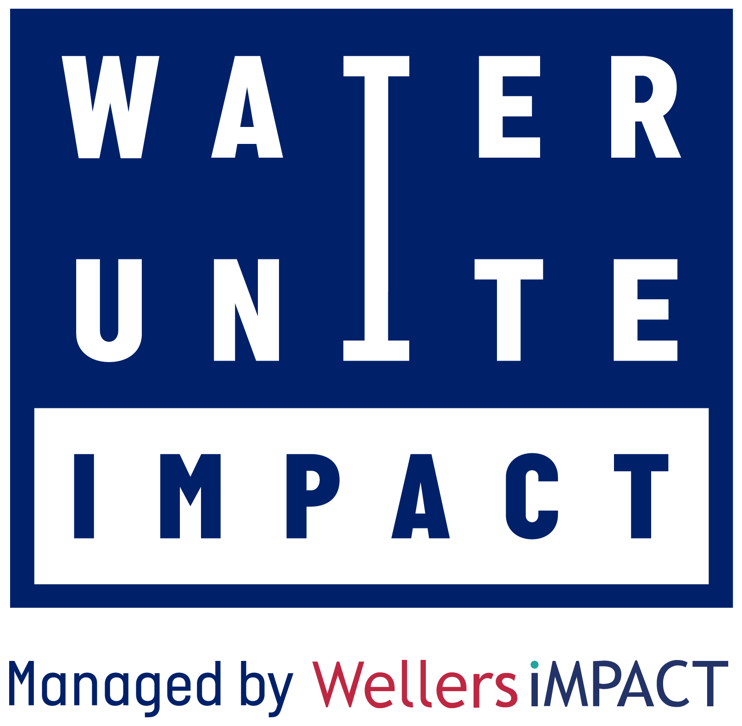
Water Unite Impact

Water Unite created Water Unite Impact, managed by FCA authorised impact investment manager Wellers Impact, in 2020. Its aim is to provide risk-tolerant capital to Small & Medium Enterprises (‘SMEs’) in the water, sanitation and plastics recycling sectors.

This investment vehicle, with planned capitalisation of US$ 100 million, invests into private sector water, sanitation and plastics recycling firms globally. It endeavours to address the gap in the funding landscape not currently filled by charitable foundations, microfinance institutions, commercial banks and traditional capital markets.

In the world today, over 785 million people do not have access to safe water sources, more than 2 billion live without sanitation facilities, and over 85% of the 300 million tonnes of plastic waste is not recycled.

Seeking to address this reality, the fund invests into private sector businesses using a catalytic capital structure relying on Water Unite’s micro-contributions from international retailers as its foundation.

HIGH RES LOGOS CAN BE FOUND HERE: https://www.waterunite.org/media-pack/

NOTES TO EDITORS:

Media contact: Connie Goring-Morris, connie@waterunite.org / +44 7872 506372

About Water Unite
Water Unite is a UK based, non-profit organisation that works in partnership with the private sector to raise and invest funds for clean water sanitation and plastics recycling. Funds are raised via voluntary donations of around one cent per litre from retailers of bottled water. Started in 2018, Water Unite is supported by The Co-operative (UK), Elior UK, The Rockefeller Foundation, Stone, Vitol and One Foundations. Water Unite aims to raise US$100-$200 million in the next 2 years.

Explainer Video: https://www.youtube.com/watch?v=9eGMv2_6TIU

Brochure and Data downloads available from https://www.waterunite.org/page/research-and-papers/
For more information please visit waterunite.org

